Directions to Jurys Inn Nottingham - Station Street, Nottingham NG2 3BJ - to BioCity – 5-10 minutes
- Turn left outside the hotel on Station St, towards London Rd.
- Turn left onto London Rd
- Cross the road and walk past the Premier Inn, turn right in front of the BBC and continue ahead.
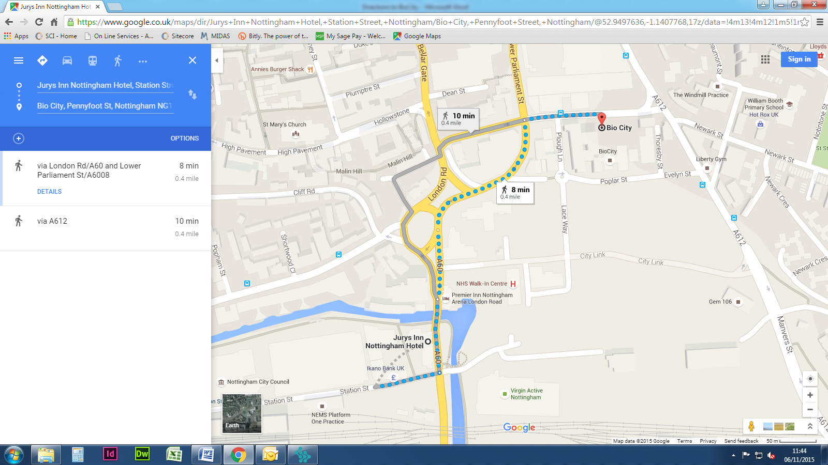
- This will bring you to the rear of BioCity on your left. Main reception is located at the front of the site on Pennyfoot Street.

