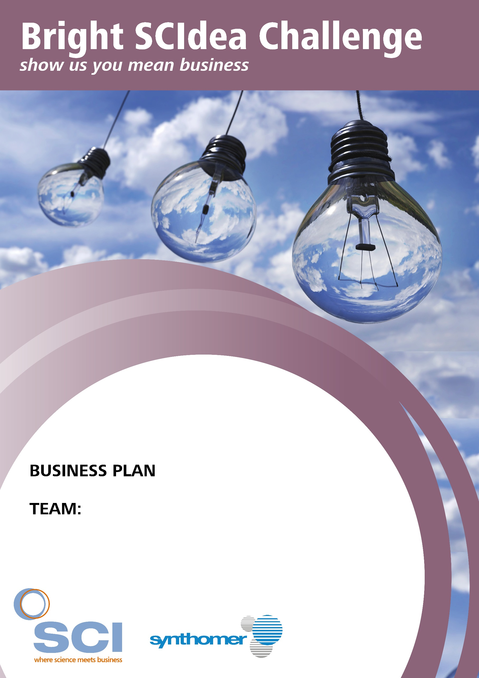

COMPETITION GUIDELINES
To help you develop your business skills, SCI has provided exclusive business training videos relating to each section of this business plan template. As you watch the training, think about the key points of each video and how this relates to the structure of your business plan.
Look for training references throughout this document and refer to the videos for more help.

SCIENTIFIC THEMES
SCI is a multi-science organisation focussing on five main themes which cover several technical interest groups. We suggest that teams choose one of these areas of science to focus their idea around: Agri-food, Energy, Environment, Health and Wellbeing, and Materials.

COMPETITION DATES
You have until Friday 15 February 2019 to complete your business plan. Submissions must be received before midnight.
Competition entrants must be available to travel to SCI, London, for the competition final on Tuesday 19 March 2019. Travel and accommodation bursaries are available for finalists*.

SUBMITTING YOUR COMPLETED BUSINESS PLAN
Once you have completed your business plan, please save your entry in the following format:
Your team name_Bright SCIdea Challenge e.g. Glucoguard_Bright SCIdea Challenge
Images
If you wish to include any images to support your submission, please clearly indicate within the document where they should be seen e.g. ‘Figure 1’, and attach the image labelled in the same way to your submission email.
Email your completed business plan and any relevant attachments to BrightSCIdea@soci.org.

*For full terms and conditions, please see the event webpage: www.soci.org/BrightSCIdea

ABOUT YOUR TEAM
Please use this space to tell us who your team are, what your roles are within the team and what your interests are outside of the competition. If you would like to add photos, please clearly label and attach these to your submission email.

YOUR BUSINESS PROPOSITION – Video 1: Defining the Market Need
What is your Bright SCIdea? (Max 250 words)
Key things to think about:
- What is the problem you are aiming to solve?
- What is your proposed solution?
- What is the market need?
- Who are your likely customers?
- Who/what are the competitors to your product or service?

SCALE UP AND MANUFACTURE – Video 2: From Lab to Market
How would you take your innovation out of the lab and into the market? (max 250 words)
Key things to think about:
- How would you take your product from small scale in the lab to a full-scale commercial product?
- Where would the product be manufactured?
- What are the likely manufacturing costs?
- How long would it take to carry out the development work to scale-up your product to commercial scale (ready for sale)?
- What are the likely development costs that would be incurred during the scaling up process?

BRANDING AND MARKETING YOUR SCIDEA – Video 3: Taking Your Product to Market
How would you brand, market and sell your finished product or service? (max 250 words)
Key things to think about:
- Who are your target customers?
- At what price would you market your product?
- How would you market the product? Would it be branded?
- How would you sell the product/which channels would you use?
- Is there Intellectual Property you need to consider protecting?
- What skills would you need in the team? Who would cover these roles and how much would the team cost (salaries etc.)?

THE INVESTMENT PROPOSITION – Video 4: Managing the Money
Your Bright SCIdea must be attractive to investors if you are going to be successful in gaining financial backing. You need to be able to demonstrate to investors that you have considered the main sources of income and the likely costs, and that you can present a viable investment proposition.
The main consideration for any investor is the cashflow forecast in the form of a Profit and Loss Account. This describes your income (cash inflows) and costs (cash outflows). An example Profit and Loss Account proforma (also known as a Cashflow document) is shown below (Figure 1). For this aspect of your business plan, we would like you to complete the blank document shown overleaf to display how your product or service is forecast to perform over a 5-year period. To help you complete the Cashflow document with ease, we have made an Excel version of this table available to download on the Bright SCIdea webpage: www.soci.org/BrightSCIdea

 | Year 1 | Year 2 | Year 3 | Year 4 | Year 5
Income
Number of Units sold | 5,000 | 6,000
Sales price per Unit | £20 | £20
Total Revenue | £100,000 | £120,000
Manufacturing costs
Cost per unit | £2 | £2
Number of Units produced | 5,000 | 6,000
Total manufacturing cost | £10,000 | £12,000
Overhead expenses
Salaries | £40,000 | £60,000
Legal | £10,000 | £5,000
Other costs* | £4,165 | £7,578
Total overheads | £86,165 | £96,578
Total costs | £96,165 | £108,578
Net Profit | £3,835 | £11,422

Figure 1. Profit and Loss Calculator, also known as a Cashflow document
*Please include a breakdown of any additional costs in the space provided on page 9.
 | Year 1 | Year 2 | Year 3 | Year 4 | Year 5
Revenue
Number of units sold
Sales price per unit (£)
Total revenue
Manufacturing costs
Cost per unit (£)
Number of units produced
Total manufacturing cost
Overhead expenses
Salaries (£)
Legal (£)
Other costs* (£)
Total overheads
Total costs
Net profit

OTHER COMMENTS
Please use this section to add in any other comments or additional material that you wish the judges to take into consideration when shortlisting.

Copyright © 2018 SCI. All Rights reserved. Registered charity number 206883.

