Guest may use the car park at the Parc Centre or at the Station Car Park on Queens Road, near to the Nottingham Train station
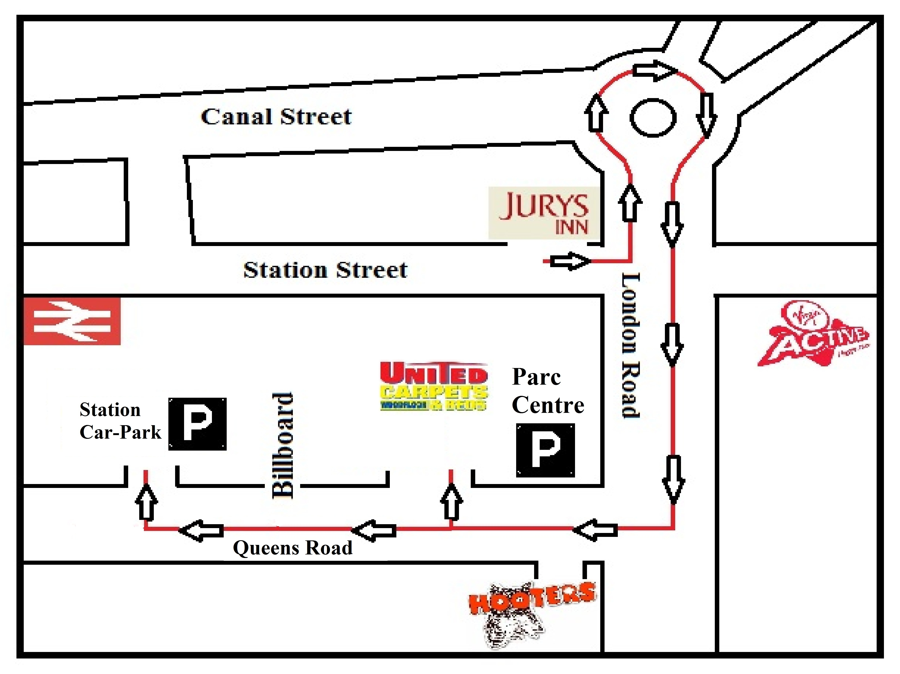

Postcode for Station Car Park is NG2 3AQ
Postcode for Parc Centre is NG2 3AS

Location
The Car Parks are 3 – 5 minute walk from the
hotel, and are located on Queens
Road. The Parc Centre offers both internal and
external parking while the Station Car Park is a
multi-storey car park with five floors with 950 spaces.

Opening hours
Station Car Park Centre Parc Centre
Monday – Thursday 6am to 11pm
Monday – Sunday 24 Hours Friday 6am to 10pm
Saturday 7am to 9pm
Sunday 7am to 11pm
*Vehicles are kept at the discretion of their owner; no responsibility is accepted by Car Park.
Charges and Payments
Rate Description | Prices at Parc Centre | Prices at Station Car Park | Payment
Over Night | £7 (4pm – 9am) |  | Pay and Display Machine
Day Rate | £3.50 (8am – 6pm) | £4 (10am – 2.30am) | Pay and Display Machine
24 Hour Rate | £11 | £7 | Pay and Display Machine
Weekend Rate | £18 (4pm on Friday to 1pm on Sunday) | £15 (Friday – Monday) | Pay Attendant (Parc Centre only)
Extra Time | £1/Hour |  | Pay and Display Machine

Only at Parc Centre
For convenience you might want to pay the attendant for the entire length of your stay so you will not have to return to your car on a daily basis.
- Please note that the car park accepts cash and card payments.
- Card payments available inside car park office
- Shuttle Bus available – for more information contact car park attendant

